1. Outputs of the project:

* The main page has options to choose any gauge’s wire you want to buy. Deploy the price according to the quantity you want get.
* Above this panel you have the navigation bar, and below you find useful information about the business.
* Inside the page “Calculate wire”, you can know what gauge’s wire you need for your installation
* Inside “Calculate savings” you’ll find the option to compare the gauge you need, with bigger gauges that you can buy, if you want savings in the longterm.

1. Design and implementation:

* Being aware of the templates made during the design, different elements that were taught in this course
* The boostrap grid was designed using the techniques of the course
* In the same way, I designed the navigation bar and other elements
* In particular, it was extremely difficult to realize the stage of building the “dist folder”

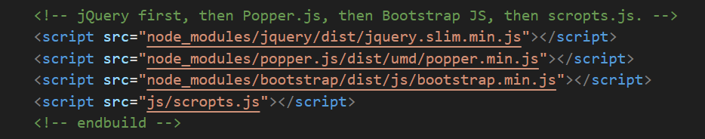

* By any reason I haven’t been able to find out. The dist folder was only built when I changed “js/scripts.js” by “js/scropts.js” ???

1. Conclusions:

* It has been interesting to know that I have achieved a complete handful of skills to develop front-end.
* However I realized that it’s extremely difficult to work with some tools, if you don’t have the correct version.